**VAISHNAVI E 231901059**

**Ex. No.: 9**

**Date: 02-04-2025**

**DEADLOCK AVOIDANCE**

**Aim:** To find out a safe sequence using Banker’s algorithm for deadlock avoidance.

**Algorithm:**

1. Initialize work=available and finish[i]=false for all values of i
2. Find an i such that both: finish[i]=false and Needi<= work
3. If no such i exists go to step 6
4. Compute work=work+allocationi
5. Assign finish[i] to true and go to step 2
6. If finish[i]==true for all i, then print safe sequence
7. Else print there is no safe sequence

**Program Code:**

#include <stdio.h>

#include <stdbool.h>

#define P 5 // Number of processes #define R 3 // Number of resources

void findSafeSequence(int processes[], int available[], int max[][R], int allocation[][R]) { int need[P][R]; bool finish[P] = {false}; int safeSequence[P]; int work[R];

// Calculate Need Matrix for (int i = 0; i < P; i++) { for (int j = 0; j < R; j++) { need[i][j] = max[i][j] - allocation[i][j];

}

}

// Initialize work as available resources

for (int i = 0; i < R; i++) {

work[i] = available[i];

}

int count = 0; while (count < P) { bool found = false; for (int i = 0; i < P; i++) {

if (!finish[i]) {

int j;

for (j = 0; j < R; j++) {

if (need[i][j] > work[j]) {

break;

}

}

if (j == R) { // If all needs are met for (int k = 0; k < R; k++) {

work[k] += allocation[i][k];

}

safeSequence[count++] = processes[i];

finish[i] = true; found = true;

}

} } if (!found) { printf("No safe sequence exists\n"); return;

}

}

// Print Safe Sequence printf("The SAFE Sequence is: "); for (int i = 0; i < P; i++) { printf("P%d", safeSequence[i]); if (i < P - 1) printf(" -> ");

} printf("\n"); } int main() { int processes[P]; int available[R]; int max[P][R];

int allocation[P][R];

// Get user input printf("Enter process IDs: "); for (int i = 0; i < P; i++) {

scanf("%d", &processes[i]);

}

printf("Enter available resources: "); for (int i = 0; i < R; i++) {

scanf("%d", &available[i]);

}

printf("Enter max resource matrix: \n"); for (int i = 0; i < P; i++) { for (int j = 0; j < R; j++) { scanf("%d", &max[i][j]);

}

}

printf("Enter allocation matrix: \n");

for (int i = 0; i < P; i++) { for (int j = 0; j < R; j++) {

scanf("%d", &allocation[i][j]);

}

}

findSafeSequence(processes, available, max, allocation); return 0;

}

**OUTPUT:**

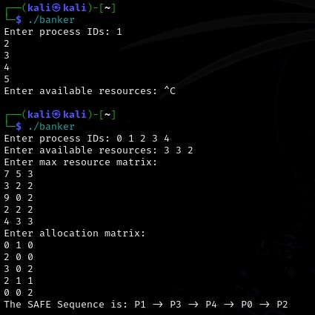

**RESULT:**

Hence,safe sequence using Banker’s algorithm for deadlock avoidance has been executed